3. Bubble Sort with Big-O Analysis

Aim
To implement the Bubble Sort algorithm using Python and analyze its Big-O time complexity.

Algorithm
- Start.
- Create an array of unsorted elements.
- Compare two adjacent elements.
- If the first element is greater than the second, swap them.
- Continue comparing adjacent elements until the end of the array.
- Repeat the process for all elements.
- After each pass, the largest unsorted element moves to its correct position.
- Display the sorted array.
- Stop.

Procedure
- Open Python IDLE, VS Code, or an online Python compiler.
- Create an unsorted array.
- Find the length of the array.
- Use nested for loops for multiple passes.
- Compare adjacent elements using an if condition.
- Swap the elements when they are in the wrong order.
- Repeat until the complete array is sorted.
- Display the sorted array.
- Analyze the time complexity as O(n²).
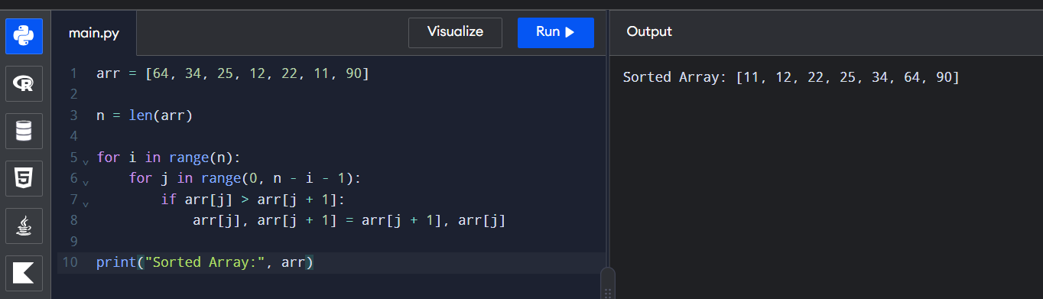

Result
Thus, the Python program successfully sorts the given array using Bubble Sort. The average and worst-case time complexity is O(n²).

